SIMATS ENGINEERING
ASSESSMENT TOOL 3

COURSE NAME: Artificial Intelligence COURSE CODE: CSA17
NAME:Gayathri.P
REG NO:192424324

COURSE OUTCOME COVERED

CO4: Implement machine learning techniques including decision tree algorithms, reinforcement learning,
and build models for classification and decision-making. (BL3)

Assessment Tool Weightage: 40%

Duration : 45 Minutes
QUESTIONS: 2 Total Marks:20

Annexure A

INTEGRATED EXPERIMENTS

Code of Conduct:

I __Gayathri(192424324)_ (Name / Reg No) certify that this submission is my original work and that I have adhered to the guidelines specified for this assessment.
I understand that any violation of academic integrity rules will result in disciplinary action.

Signature of the student:
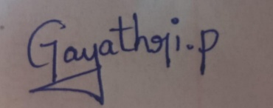

Annexure A

INTEGRATED EXPERIMENTS

Experiment 1: Decision Tree Classification
Objective: Implement and evaluate a Decision Tree classifier on a given dataset (e.g., Iris / Play-Tennis) using Python / any ML library.

(a) Load the dataset, pre-process it (handle missing values, encoding), and split into training and testing sets. Display the first 5 rows and data types.
(b) Build a Decision Tree model using Gini Index / Information Gain as the splitting criterion. Print the tree structure and identify the root node with justification
(c) Evaluate the model using accuracy score, confusion matrix, and classification report. Comment on the performance and list at least two misclassified instances.

Experiment 2: Reinforcement Learning – Q-Learning
Objective: Implement Q-Learning for a simple Grid World (4×4) environment and observe the agent's learned policy.

(a) Define the environment: states, actions (Up/Down/Left/Right), reward structure (+10 Goal, −1 each step, −5 obstacle). Initialize the Q-table with zeros and state the hyperparameters (α, γ, ε).
(b) Run the Q-Learning algorithm for at least 100 episodes. Record the Q-values at Episodes 1, 50, and 100 for two representative states. Show how the Q-table evolves.
(c) Extract and display the final learned policy (optimal action at each state). Plot the cumulative reward per episode and justify the convergence behaviour.

RUBRICS FOR CALCULATION: 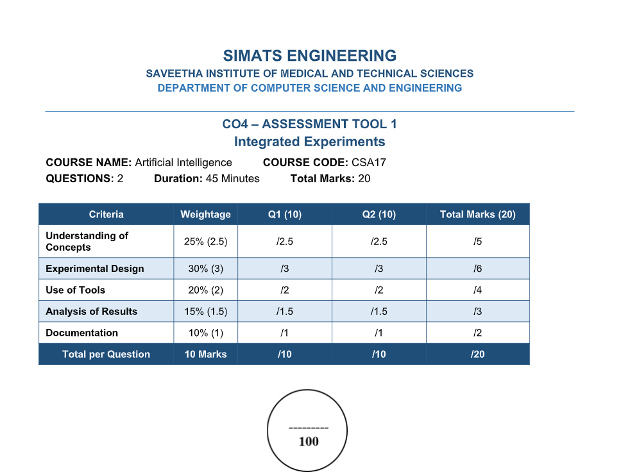

ANSWERS
EXPERIMENT 1: DECISION TREE CLASSIFICATION
Objective
To implement and evaluate a Decision Tree classifier on the Iris dataset using Python and Scikit-learn. The experiment demonstrates supervised inductive learning, preprocessing, tree construction, root-node selection, classification evaluation, and interpretation of errors.
(a) Load, Pre-process and Split the Dataset
Step 1: Load the Iris dataset
The Iris dataset contains 150 observations, four numerical features—sepal length, sepal width, petal length and petal width—and three target classes: Setosa, Versicolor and Virginica.
From_sklearn.datasets_import_load_iris
import_pandas_as_pd
iris_=load_iris()
df=pd.DataFrame(iris.data,_columns=iris.feature_names
df["target"]=iris.target
df["species"]=df["target"].map(dict(enumerate(iris.target_names)))
print(df.head())
print(df.dtypes)
Step 2: Expected first five rows
5.1 3.5 1.4 0.2 0 setosa
4.9 3.0 1.4 0.2 0 setosa
4.7 3.2 1.3 0.2 0 setosa
4.6 3.1 1.5 0.2 0 setosa
5.0 3.6 1.4 0.2 0 setosa
Step 3: Check missing values and data types
print(df.dtypes)
print(df.isnull().sum())
The standard Iris dataset has no missing values, so imputation is not required.
The four predictors are numerical; the target is an integer class label.
Decision Trees do not require feature normalisation because splitting uses thresholds.
The target is already encoded as 0, 1 and 2.
Step 4: Split the data 70:30
From_sklearn.model_selection_import_train_test_split
X=df[iris.feature_names]
y=df["target"]
X_train,X_test,y_train,y_test=train_test_split(
X,y,test_size=0.30,random_state=42,stratify=y
)
The 70:30 split gives sufficient data for learning while keeping an independent test set. Stratification preserves class proportions.
(b) Build the Decision Tree
Step 1: Train the model
From_sklearn.tree_import_DecisionTreeClassifier
model=DecisionTreeClassifier(
criterion="gini",
random_state=42
)
model.fit(X_train,y_train)
Step 2: Print the tree structure_
From_sklearn.tree_import_export_text
print(export_text(model,feature_names=list(X.columns)))
Step 3: Root-node justification
The root is selected by the split that gives the largest reduction in impurity. For Gini Index, Gini(S)=1−Σpᵢ². The weighted child-node Gini is compared for candidate features and thresholds. In Iris data, petal measurements usually provide the strongest first separation because Setosa is clearly separated from the other classes. The exact root and threshold must be taken from the printed trained tree rather than assumed.
From_sklearn.tree_import_plot_tree
import_matplotlib.pyplot_as_plt
plt.figure(figsize=(14,8))
plot_tree(model,feature_names=iris.feature_names,
class_names=iris.target_names,filled=True)
plt.show()
(c) Evaluate the Model
From_sklearn.metrics_import_accuracy_score,confusion_matrix,classification_report
y_pred=model.predict(X_test)
print("Accuracy:",accuracy_score(y_test,y_pred))
print("Confusion_Matrix:")
print(confusion_matrix(y_test,y_pred))
print(classification_report(y_test,y_pred,target_names=iris.target_names))
The Decision Tree is expected to achieve high accuracy on Iris. Setosa is normally classified almost perfectly, while most errors, if present, occur between Versicolor and Virginica because their measurements overlap.
Step 4: Identify misclassified instances
errors=X_test.index[y_test!=y_pred]
for_idx_in_errors:
print("Index:",idx,
"Actual:",iris.target_names[y_test.loc[idx]],
"Features:",X_test.loc[idx].to_dict())
The code above lists the actual misclassified observations for the selected split. If fewer than two errors occur, they should not be artificially created; the experiment should report the actual number.

EXPERIMENT 2: REINFORCEMENT LEARNING – Q-LEARNING
Objective
To implement Q-Learning in a 4×4 Grid World, train an agent for at least 100 episodes, record Q-values, display the final learned policy, and analyse cumulative reward convergence.
(a) Environment Definition
Step 1: States
There are 16 states arranged as a 4×4 grid:
0 1 2 3
4 5 6 7
8 9 10 11
12 13 14 15
State 15 is the goal. Example obstacle states are 5 and 10.
Step 2: Actions
0 = Up
1 = Down
2 = Left
3 = Right
Step 3: Rewards
+10 for reaching the goal.
−1 for each normal step.
−5 for entering an obstacle.
Step 4: Q-table and hyperparameters
The Q-table has 16 rows and 4 action columns and is initially filled with zeros.
Learning rate α = 0.8
Discount factor γ = 0.95
Exploration rate ε = 1.0 initially
Minimum ε = 0.05
Epsilon decay = 0.995
Episodes = 100
Step 5: Q-Learning equation
Q(s,a) ← Q(s,a) + α[r + γ max Q(s′,a′) − Q(s,a)]
Q-Learning combines the immediate reward with the estimated future value. The agent therefore learns which actions are useful for reaching the goal efficiently.
Step 6: Python implementation
Import_numpy_as_np
import_random
Q=np.zeros((16,4))
alpha=0.8
gamma=0.95
epsilon=1.0
epsilon_min=0.05
epsilon_decay=0.995
goal=15
obstacles={5,10}
def_step(state,action):
row,col=divmod(state,4)
if_action==0:_nr,nc=row-1,col
elif_action==1_nr,nc=row+1,col
elif_action==2:_nr,nc=row,col-1
else:_nr,nc=row,col+1
if_nr<0_o_nr>=4_nc<0_or_nc>=4:
return_state,-5,False
ns=nr*4+nc
ifns_in_obstacles:
return_state,-5,False
if_ns==goal:
return_ns,10,True
return ns,-1,False
(b) Train for 100 Episodes
rewards=[]
tracked={}
for_episod_einrange(1,101):
state=0
total=0
for_t_in_range(100):
if_random.random()<epsilon:
action=random.randrange(4)
else:
action=np.argmax(Q[state])
next_state,reward,done=step(state,action)
Q[state,action]+=alpha*(
reward+gamma*np.max(Q[next_state])
-Q[state,action]
)
state=next_state
total+=reward
if_done:
break
rewards.append(total)
if_episode_in_[1,50,100]:
tracked[episode]=Q.copy()
epsilon=max(epsilon_min,epsilon*epsilon_decay)
print(np.round(Q,3))
Step 2: Record two representative states
For_epin_[1,50,100]:
print("Episode",ep)
print("State_0_:",np.round(tracked[ep][0],3))
print("State 14:",np.round(tracked[ep][14],3))
Episode 1 generally contains little useful knowledge, so Q-values remain close to zero except for values learned from early rewards or penalties. By Episode 50, useful actions begin to receive higher values. By Episode 100, the Q-values should show a stronger preference for actions leading safely toward the goal. Exact numerical values depend on the random seed and environment transitions.
(c) Final Learned Policy
actions=["Up","Down","Left","Right"]
policy=[]
forstate_inrange(16):
ifstate==goal:
policy.append("G")
elifstateinobstacles:
policy.append("X")
else:
policy.append(actions[np.argmax(Q[state])])
for_in_range(4):
print(policy[r*4:(r+1)*4])
The final policy is π(s)=argmaxₐQ(s,a). G represents the goal and X represents an obstacle. A successful policy should guide the agent toward state 15 while avoiding obstacle states.
Step 2: Plot cumulative reward
Import_matplotlib.pyplotasplt
cumulative=np.cumsum(rewards)
plt.figure(figsize=(10,5))
plt.plot(cumulative)
plt.xlabel("Episode")
plt.ylabel("Cumulative_Reward")
plt.title("CumulativeReward_during_Q-Learning")
plt.grid(True)
plt.show()
Step 3: Convergence justification
At the beginning, the agent explores and often receives negative rewards. As Q-values are updated, actions leading toward the goal become more valuable. Epsilon decreases, so exploitation becomes more frequent. Convergence is indicated when Q-values change very little over successive evaluation periods and the moving-average episode reward becomes stable. A practical numerical criterion is a maximum Q-value change below 0.01 for several consecutive evaluation windows.
AI Concepts Demonstrated
Decision Tree classification demonstrates supervised inductive learning.
Gini Index demonstrates impurity-based feature splitting.
Train-test splitting demonstrates model generalisation evaluation.
Q-Learning demonstrates model-free Reinforcement Learning.
The Grid World represents an MDP with states, actions, rewards and transitions.
Epsilon-greedy selection balances exploration and exploitation.
Temporal-difference updates combine current rewards with future value estimates.
The learned policy selects the highest-value action for each state.
RESULT
The Decision Tree experiment demonstrates the complete AI classification workflow from dataset preparation to prediction and evaluation. The Q-Learning experiment demonstrates how an AI agent learns an optimal sequential decision policy through interaction, rewards and repeated Q-table updates. Together, the experiments demonstrate supervised learning and reinforcement learning approaches for intelligent decision-making.

